Course Project – Analysis Documentation

Shaun Pritchard

Rasmussen College

CDA3315C

Alan Dennis

July,17 2020

**Use case:** Project Use-Case-001

**Created by:** S.P

**Date Created:** 07-10-2020

**Actors:** Lead, Users, Subject Matter Experts (SME)

**Priority:** 1

**Project Summary:**

This project will facilitate a cloud web-based inventory system that will inventory database structures with output responses based on user input. I would like to abstract the database modeling to output the design structure for input queries based on the relationships of the modeling and layered database architecture for enterprise systems. This will be implemented throughout the project schedule.(See Project Schedule)

**Project Schedule:**

6 weeks is proposed based on the following schedule to complete the proposed enterprise architecture system implementation.

|  |  |  |
| --- | --- | --- |
|  | **Project Schedule** | |
| **Description** | **Action** |
| **Week 1** | Use-Case | Create New use-case and define application purpose. |
| **Week2** | Modeling baseline & Database | Define software & system requirements. Model database |
| **Week3** | Web & interface development | Create web components and interfaces to communicate with backend |
| **Week4** | Testing | Document the user acceptance testing environment |
| **Week 5** | Deployment | Document the definition of scope creep create maintenance documentation |
| **Week 6** | Security & reporting | Enhance the project documentation |

**Project Components**

Will explain and consider the risks and analysis for software requirements, hardware requirements, staffing, timelines, and project costs of the cloud-web based inventory system.

**Risk**

Time could be a factor that would threaten the projects success variants of details and complexity could be cause. Also, unseen changes and constraints could pose factors that would hinder the timeline in question for the project’s completion. This complexity and constraints could come from database modeling and building interfaces to the front-end web application.

**Analysis**

Overall, there is not enough data to propose a full analysis of the overall project. Based on system constraints and abstraction the web application seems to be a fairly easy task with minimum milestones which can be easily implemented.

**Use case diagram:**

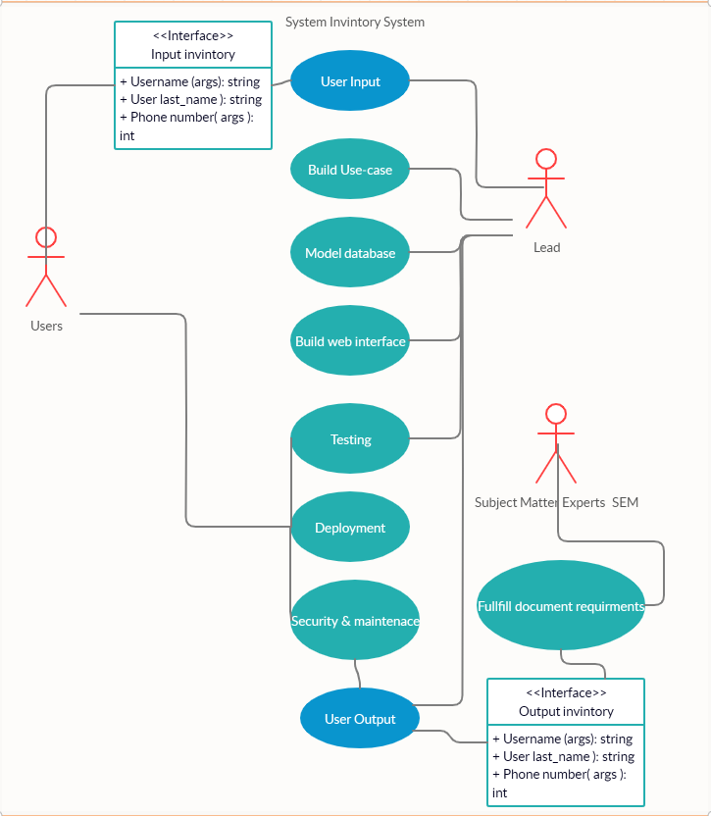

**Business Rules:**

Business rule is meant to help everyone understand the logic of each area of the service or product that is being developed. These rules will apply to a CRUD based inventory system for student registration at Rasmussen College. Business rules are denoted with (**BR**-#)

**BR-1** Users will be able to access a responsive web-based interface capturing user input from 3 input field types  First_Name, Last_Name and Telephone_number to register to Rasmussen College.

**BR-2** First_Name, Last_Name and Telephone number input data will be stored in MySQL database backend hosted on an Azure server.

**BR-3** PHP scripting will implement database access, query, and logic between backend MySQL database and the user input data.

**BR-4** An HTML form input “Submit” button will be accessible below the main user input fields to capture input user data to facilitate the query of the MySQL database where user input data will be stored via the PHP logic.

**BR-5** Below the input form and “Submit” button on the user form a 4-column output table will be generated based on the PHP code logic that will access the stored data from the MySQL database; displaying the data fields plus the active MySQL database the current data is stored in for users to visualize.

**BR-6** Below the output table area of the interface there will be a red JavaScript input button called “Delete” implemented through PHP scripting that will delete the latest row from the given output table and the MySQL data base to Unregister a submitted student, omitting their name from the list.

**BR-7** Below the “Delete” button will be another script bas generated table that will show all current and active tables in the MySQL data base through logic that will read and update the actual table programmatically. Any new tables added to the database will be added to this table after page. This will occur from Update asynchronous logic that will check and update the current tables through a procedurally script set Time out function. This will facilitate the “Update proponents of the CRUD implementation.

**BR-8** Below the Active database table there will be another form button that will generate an active alert with current database input data of registered users for READ Only implementation of the CRUD app.

**BR-9** Interface will be styled with bootstrap being responsive to mobile devices and have a clean appeal to all users.

**System Requirements:**

**Functional requirements** *(denoted as* ***F****- plus number)*

1. Setup and install web app service with MySQL on Azure service.
2. Create new MySQL database tables.
3. Build reporting table and load data.
4. Create a new PHP based web page user interface.
5. Create PHP connection strings.
6. Write a PHP process database activity.
7. Write CSS syntax to format web user interface.
8. Publish PHP based web application to Azure cloud services.
9. Use developer tools to modify and fix inefficiencies with the web application.
10. Code base used for user interface will consist of HTML, CSS, JavaScript, PHP and MySQL
11. Web server will be developed as a service using Azure
12. MySQL database will be implemented and set up through Azure service.

**Behavioral requirements** *(denoted as* ***B****- plus number)*

1. Users form to register students **First_Name** input will be stored in MySQL web server database back end first table field.
2. Users form to register students **Last_Name** input will be stored in MySQL web server database back end first table field.
3. Users form to register students **Telephone_number to** input will be stored in MySQL web server database back end first table field.
4. User will press “Submit button to query database and store data input values into the MySQL database selected table.
5. After user submission is handled by the “Submit” button. the output table below the button will populate with current **active_database_table** name value and the submitted user input form values, per row.
6. User will be able to press the “Delete button will be under the output table with the ability to delete the latest submission of data in the output table and the active database table in MySQL.
7. User will be able to view the Active database Table directory below the “Delete” button to show all active tables in the current MySQL database back-end implementation.
8. User will be able to press a readme submit button to output all database values in the output table to read only an alert message as read only data.

**Requirement Priorities:**

This section will outline the business requirements as well as their importance to the project. Priority ratings should include critical, high, medium, low, and future. Begin with critical needs and work down to low and future requirements.

|  |  |  |  |
| --- | --- | --- | --- |
| Priority | Description | Rationale | Stakeholders |
| *Priority level* | *Description of the requirement* | *Why is requirement included?* | *Departments or teams impacted* |
| High | **BR-1** | Register users | IT admin |
| High | **BR-2** | Register users | IT admin |
| High | **BR-3** | Register users | IT admin |
| Med | **BR-5** | Register users | IT admin |
| Med | **BR-7** | User interface | IT admin |
| High | **F-1** | Implement input data | Developers |
| High | **F-4** | Implement input data | Developers |
| Med | **F-5** | Implement input data | Developers |
| Low | **F-7** | Database implementation | Developers |
| High | **F-8** | Frontend development | Developers |
| High | **B-1** | Inventory create data | User & Admin |
| High | **B-2** | Inventory create data | User & Admin |
| High | **B-3** | Inventory create data | User & Admin |
| Med | **B-5** | Inventory update data | User & Admin |
| Med | **B-6** | Inventory delete data | User & Admin |
| Low | **B-8** | Inventory read data | User & Admin |

*Source:* <https://www.modernanalyst.com/Resources/Articles/tabid/115/ID/1442/Use-Cases-and-Business-Rules-Can-They-Work-Together.aspx>

References

1